Suggested searches based on recommendations in the National Review of Asthma Deaths

- The clinical record should be checked to confirm the basis for needing a review before inviting those found by the searches in for review.

Set 1: People identified in these searches should be called in for review with an urgency appropriate to the individual circumstances.

Importing searches into Emis web;

How to import Searches into Emis Web.
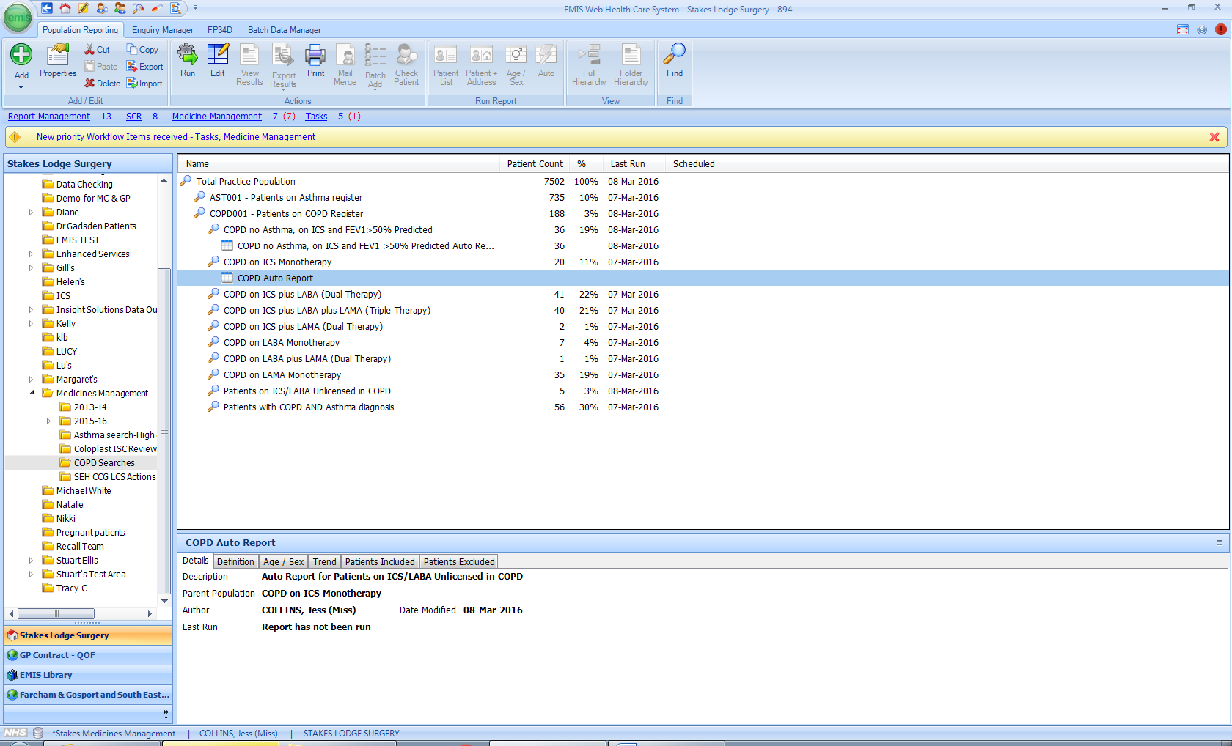
From the population reporting menu, select import

The following box will appear; click here to select the file location of the import
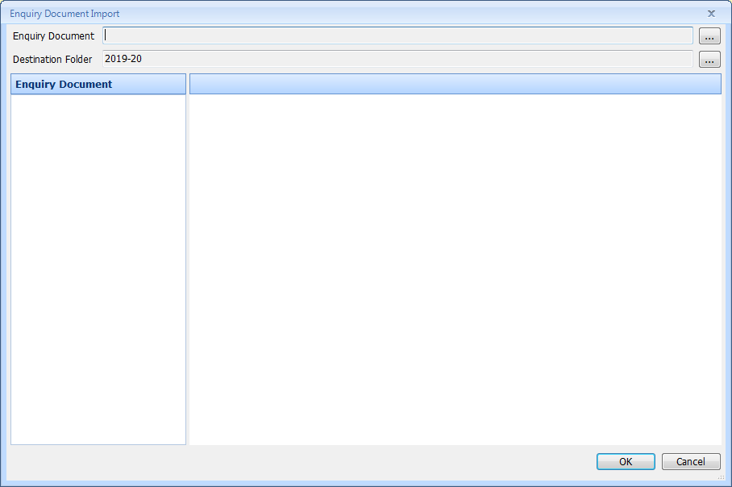

Choose a suitable location for your search. You should see the folder/search files displayed
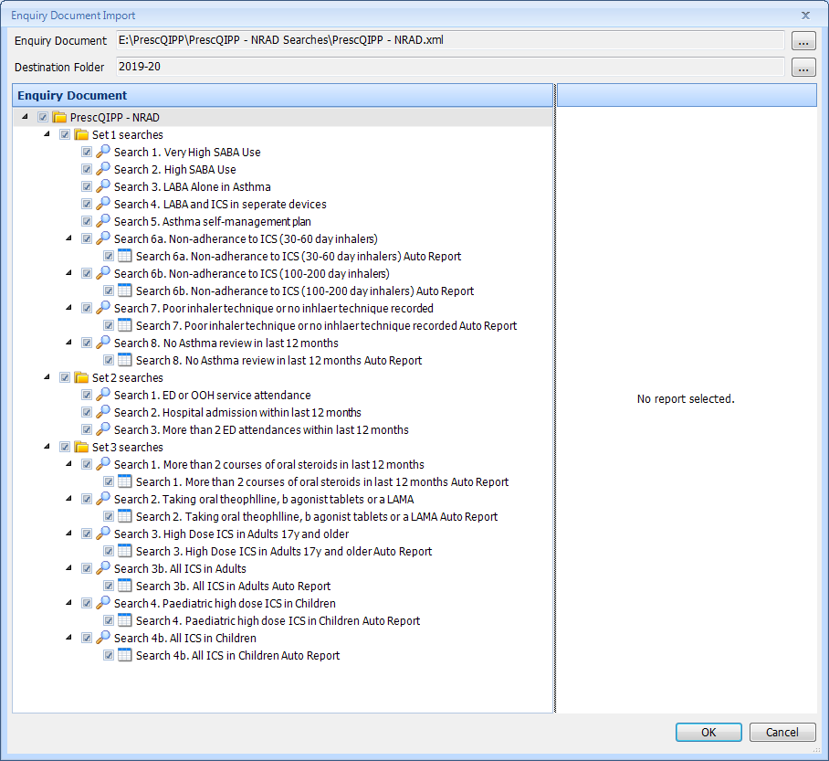
Once imported, highlight the folder called “ PrescQIPP – NRAD” and select “Run”
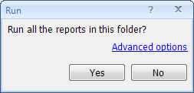 Click “yes”
Folder - Set 1 searches
Title | Age range | Diagnosis | Drug | Search | AND | OR | Suggested actions
Very High SABA use | Any | Asthma | Salbutamol inhaler (including all brands)  Terbutaline inhaler (including brands) | 6 or more inhalers prescribed in last 6 months  Search 1. Very high SABA use |  |  | Review asthma management urgently.
High SABA | Any | Asthma | Salbutamol inhaler (including all brands)  Terbutaline inhaler (including brands) | 3 or more inhalers prescribed in last 12 months  Search 2. High SABA use  (Excludes patients picked up in search 1. Very high SABA use) |  |  | Review asthma management.
LABA alone in asthma | Any | Asthma | Salmeterol  Formoterol  Bambuterol  (All including brands but excluding compound preparations) | On active repeat prescription (and being issued)  Search .3 LABA alone in asthma.  Excludes patient with an issue of ICS in last 2 months. | NO concurrent prescribing of inhaled corticosteroid- single products (exclude compound preparations) |  | Review. Potential changes to treatment include adding ICS (in combination inhaler) or stopping LABA, depending on individual circumstances.
LABA and ICS in separate devices | Any | Asthma | Salmeterol  Formoterol  Bambuterol  (All including brands but excluding compound preparations) | On active repeat prescription (and being issued)  Search 4. LABA and ICS in separate devices | Concurrent prescribing of inhaled corticosteroid- single products (exclude compound preparations) |  | Consider changing to a combined inhaler.
Asthma self- management plan* | Any | Asthma |  | NOT Issued with an asthma action plan in the last 12 months.  Search 5. Asthma self-management plan  No read coded entry* within the last 12 months. |  | Asthma action plan not documented | Review and issue an asthma action plan. Record in clinical notes.
Non-adherence to ICS | Any | Asthma | All ICS including combination products with LABA | Less than 12 inhalers in the last 12 months  N.B. Search results will need to be reviewed manually to exclude people appropriately using products that do not require ordering every month e.g. a 200 dose ICS inhaler prescribed at 1 puff twice a day may only need to be issued 4 times a year.  Search 6a. Non-adherence to ICS (30 and 60 day inhalers) includes all ICS and combination ICS excluding Clenil, Qvar, budelin and Soprobec inhalers. Searches for less than 12 issues or 7 issues in last 12 months.  Search 6b. non-adherence to ICS (100 and 200 day inhalers)  Includes all Clenil, Qvar and Soprobec, budelin inhalers.  Searches for less than 6 or 4 issues in last 12 months | You will need to check that the patients identified are having 1 inhaler per prescription, and that the directions reflect 30 day use.  Remove any patients on inhalers with directions which indicate that they will last longer than this eg Fostair 100/6  1 puff bd. |  | Review. Identify and address barriers to adherence.
Poor inhaler technique or no inhaler technique recorded | Any | Asthma or COPD | All inhalers | Poor inhaler technique recorded in last 12 months  Search  Search 7. Poor or no inhaler technique recorded | - | No inhaler technique assessment recorded | Arrange training with an appropriately skilled health care professional.
No asthma review in the last 12 months** | Any | Asthma | All inhalers | NO asthma review in the last 12 months.  Search 8. No Asthma review in last 12 months  Excludes those excepted from asthma register, asthma resolved, refuses monitoring within last year only. |  | Asthma review not documented | Review asthma management.

*Include the following under asthma management plan  Asthma management plan given (663U)  Change in asthma management plan (XaIQ4) 66Y5  Asthma clinical management plan (XaJYe) 8CR0  Patient has a written asthma personal action plan (XaRFi) 8CMA0  Asthma self-management plan review (XaYZB) 661N1  Asthma self-management plan agreed (XaYb8) 661M1  red = emis web | **Include the following under asthma review  Codes as per QOF;  Change in Asthma management plan 66Y5  Step up change in asthma management plan 66Y9  Step down change in asthma management plan 66YA  Asthma annual review 669J  Asthma follow-up 66YK  Asthma review by college of physicians three questions 66Yp  Asthma monitored by nurse 66YQ  Asthma monitored by doctor 66YR  Asthma medication review 8B3j  Asthma monitoring check done 9OJA  Asthma monitored 9OJA-1

Set 2: People identified in these searches should have received appropriate follow-up. It should be arranged with appropriate urgency for those that have not.
Folder - Set 2 searches
Title | Age range | Diagnosis | Drug | Search | AND | OR | Suggested actions
ED or OOH service attendance due to asthma attack | Any | Asthma | Any | Asthma exacerbation/ attack in the last 12 months  Search 1. ED or OOH service attendance  Search will give date/type of event | ED or OOH | NOTE: this will not necessary be related to asthma so users will need to check notes. | Follow-up arrangements must be made after every attendance at an ED or OOH service for an asthma attack (and see below).
Hospital admission for asthma | Any | Asthma | Any | Asthma exacerbation/ attack in the last 12 months  Search 2. Hospital admission within the last 12 months.  Search will give date/type of event | Hospital admission | NOTE: this will not necessary be related to asthma so users will need to check notes. | Secondary care follow-up should be arranged after every hospital admission for asthma.
≥ 2 ED attendances for asthma attack in the last 12 months | Any | Asthma | Any | Asthma exacerbation/ attack in the last 12 months  Search 3. More than 2 ED attendances within last 12 months.  Search will give date/type of event | ≥ 2 ED attendances for asthma attack in the last 12 months | NOTE: this will not necessary be related to asthma so users will need to check notes. | Secondary care follow-up should be arranged for those with ≥ 2 ED attendances for asthma attack in the last 12 months.

Set 3: People identified in these searches should be under the care of an asthma specialist. Appropriate review and referral should be undertaken for those that are not.
Folder - Set 3 searches
Title | Age range | Diagnosis | Drug | Search | AND | OR | Suggested actions
More than 2 courses of oral steroids in last 12 months | Any | Asthma | All prednisolone oral formulations | More than 2 courses prescribed in the last 12 months.  Search 1. More than 2 courses of oral steroids in last 12 months  More than or equal to 2 issues in the last 12 months. | 9NNX or 698509001 Under care of asthma nurse specialist  8HHJ or 413087007 Referral to respiratory nurse specialist  9N2l0 or 788741000000103 Seen by respiratory nurse specialist  9NNf2 or 305476004 Under care of respiratory physician  8H4g or 306275005 Referral to respiratory physician  9N2g or 305665008 Seen by respiratory physician |  | People with asthma must be referred to a specialist asthma service if they have required more than 2 courses of systemic corticosteroids in the last 12 months.
Taking theophylline, ß-agonist tablets or LAMA | Any | Asthma | All oral formulations of  theophylline, salbutamol and bambuterol.  All inhaled tiotropium (Note: only Respimat licensed for asthma). | Search 2. Taking oral theophlline, b agonist tablets or a LAMA  All current | 9NNX or 698509001 Under care of asthma nurse specialist  8HHJ or 413087007 Referral to respiratory nurse specialist  9N2l0 or 788741000000103 Seen by respiratory nurse specialist  9NNf2 or 305476004 Under care of respiratory physician  8H4g or 306275005 Referral to respiratory physician  9N2g or 305665008 Seen by respiratory physician |  | Determine if there is a clinical need. People using any of these agents should generally be under the care of an asthma specialist.
High dose ICS in adults | ≥ 17 years | Asthma | All inhaled corticosteroids including combination products with LABA | ICS or ICS/LABA being issued at the frequency outlined in Appendix 1.  3a –high dose ICS in Adults  Patients 17y> on ICS having the max qty per month per issue. looks at 1 month prescribing.  3b – All ICS in Adults  all patients 17y> on ICS as current. To pick up all doses and qtys. All issued within last 3 months. | 9NNX or 698509001 Under care of asthma nurse specialist  8HHJ or 413087007 Referral to respiratory nurse specialist  9N2l0 or 788741000000103 Seen by respiratory nurse specialist  9NNf2 or 305476004 Under care of respiratory physician  8H4g or 306275005 Referral to respiratory physician  9N2g or 305665008 Seen by respiratory physician |  | Adults using high dose ICS should generally be under the care of an asthma specialist.  Consider if attempting a reduction in steroid dose is appropriate in stable patients.
Paediatric high dose ICS† in children and young people | ≤ 16 years | Asthma | All inhaled corticosteroids including combination products with LABA | ICS or ICS/LABA being issued at the frequency outlined in Appendix 2.  as above  4a – Paediatric high dose ICS in children  Patients 16y< on ICS having the max qty per month per issue. looks at 1 month prescribing.  4b – All ICS in children  all patients 16y< on ICS as current. To pick up all doses and qtys. All issued within last 3 months. | 9NNX or 698509001 Under care of asthma nurse specialist  8HHJ or 413087007 Referral to respiratory nurse specialist  9N2l0 or 788741000000103 Seen by respiratory nurse specialist  9NNf2 or 305476004 Under care of respiratory physician  8H4g or 306275005 Referral to respiratory physician  9N2g or 305665008 Seen by respiratory physician |  | Children and young people using paediatric high dose ICS† should be under the care of an asthma specialist.  Consider if attempting a reduction in steroid dose is appropriate in stable patients.
† ICS dosing in older children: for some ICS products, the licensed dose for older children is the same as the adult dose i.e. for some products, ‘paediatric’ high dose (as defined by NICE) may not be a high dose for older children/adolescents. This should be considered on a case-by-case basis for older children found by the search.

Set 3 searches can also be combined with the set 1 search ‘No asthma review in the last 12 months’ to identify people that may be a high priority for review.
Key
SABA – short-acting beta agonist
LABA - long-acting beta agonist
LAMA – long-acting muscarinic antagonists
ED – emergency department
OOH – out of hours

Appendix 1
High dose inhaled corticosteroids for adults aged 17 years and over with a diagnosis of asthma
The search will identify prescribing in the last 6 months for patients who have had, on average, the number of inhalers per month that suggest they are taking a high dose inhaled corticosteroid. This is calculated as follows:
Number of inhalers per month that signify high dose ICS¹
1 x 30 days
A
=

number of doses in inhaler
number of puffs needed to give total daily dose of high dose ICS¹

where A =

Please note the following:
- Not all products included in this search are licensed for the full age group specified (i.e. some are licensed for 18+ years). Products have been categorised based on their ICS content, without consideration of whether the product is licensed for a particular age group.
- The search will not identify people prescribed high dose ICS that are underordering.
- The search does not take into account reliever doses of ICS + LABA where the person uses a MART regimen, which must be considered on a case-by-case basis, where applicable.
This search can also be combined with the set 1 search ‘No asthma review in the last 12 months’ to identify people that may be a high priority for review.

References
- Based on National Institute for Health and Care Excellence (NICE). Inhaled corticosteroid doses for NICE’s asthma guideline. Issued 12/02/18, last update July 2018. Accessed via https://www.nice.org.uk/guidance/ng80/resources.
Appendix 2
Paediatric high dose inhaled corticosteroids for children under 17 with a diagnosis of asthma
The search will identify prescribing in the last 6 months for patients who have had, on average, the number of inhalers per month that suggest they are taking a paediatric high dose inhaled corticosteroid. This is calculated as follows:
Number of inhalers per month that signify paediatric high dose ICS¹

=

1 x 30 days
A

number of doses in inhaler
number of puffs needed to give total daily dose of paediatric high dose ICS¹
where A =

Please note the following:
- Not all products included in this search are licensed for the age group specified. Products have been categorised based on their ICS content, without consideration of whether the product is licensed for a particular age group.
- The search will not identify people prescribed paediatric high dose ICS that are underordering.
- The search does not take into account reliever doses of ICS + LABA where the person uses a MART regimen, which must be considered on a case-by-case basis, where applicable.
- For some ICS products, the licensed dose for older children is the same as the adult dose i.e. for some products, ‘paediatric’ high dose (as defined by NICE²) may not be a high dose for older children/adolescents. This should be considered on a case-by-case basis for older children found by the search.
- Where NICE have not defined the paediatric high dose¹ for a particular drug (as for fluticasone furoate and mometasone furoate), the search will return all children under 17 years old prescribed these products for review manually. These products are (for the most part) not licensed in this age group.
This search can also be combined with the set 1 search ‘No asthma review in the last 12 months’ to identify people that may be a high priority for review.

References
- Based on National Institute for Health and Care Excellence (NICE). Inhaled corticosteroid doses for NICE’s asthma guideline. Issued 12/02/18, last update July 2018. Accessed via https://www.nice.org.uk/guidance/ng80/resources.
- National Institute for Health and Care Excellence (NICE). Asthma: diagnosis, monitoring and chronic asthma management (NG80). Issued 29/11/17, last updated January 2018. Accessed via www.nice.org.uk/guidance/ng80

